Network Cabels and Connectors Assignment

1. T568B Cat6 Cable Diagram
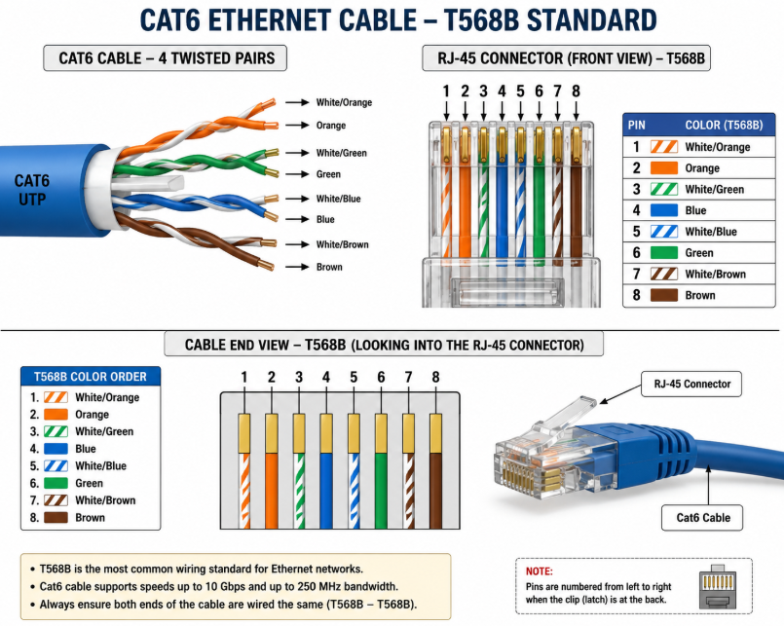

2. Types of Network Cables
Cable Type | Device/App | Use | Why
Cat5e | WiFi Router | Home Network | Low cost and good speed
Cat6 | Gaming PC / POS Terminal | Gaming and business | Higher speed and reliability
Fiber Optic | IPL Streaming Server | Video streaming | Very high speed and long distance

3. RJ-45 Crimping Process
Step 1: Cut the cable to the required length.
Step 2: Remove the outer jacket carefully.
Step 3: Arrange the wires in T568B color order.
Step 4: Straighten and trim the wires evenly.
Step 5: Insert the wires into the RJ-45 connector.
Step 6: Use a crimping tool to attach the connector.
Step 7: Test the cable using a cable tester.
Common Mistakes:
1. Wrong wire color order.
2. Not pushing the wires fully into the connector.

4. Gaming Zone for IPL Screening
Recommended Cable: Cat6 Ethernet Cable
Recommended Connector: RJ-45
Reason:
Cat6 provides high-speed and reliable connections for gaming consoles and screens. RJ-45 connectors are easy to use and commonly supported by network devices.

5. Photo of Network Cable or Connector
